Biological sciences – Science and Engineering Faculty

Queensland University of Technology

**BIODIVERSITY VALUE OF REGROWTH VEGETATION: AVIAN ASSEMBLAGES IN REGROWTH *ACACIA* WOODLANDS IN SEMI-ARID EASTERN AUSTRALIA**

by

Brendan Doohan (BScBiol)

2018

Supervisor:

Dr. Susan Fuller

Queensland University of Technology

A thesis submitted in partial fulfilment of the requirements of the degree of Bachelor of Biological Science (Honours) at the Queensland University of Technology

Conflict of interest: To the author’s knowledge there are no conflicts of interests. The author has received no funding beyond a Government assisted placement within the honours degree. The author received no additional funding from external sources to complete this work, nor does the author stand to receive any financial benefit from the outcome of this publication. There are no relationships with external parties (personal or organization) which would influence the collecting, interpretation or presentation of this work.

The work contained in this thesis has not been previously submitted for a degree or diploma at any other higher education institution. To the best of my knowledge and belief, the thesis contains no material previously published or written by another person except where due reference is made.

Signed: Brendan Doohan…………………

Date: 12/06/18…………………………...

# Title

Biodiversity value of regrowth vegetation: avian assemblages in regrowth *Acacia* woodlands in semi-arid eastern Australia.

Authors

Brendan Doohan1,Jeanette Kemp2,Susan Fuller1

1School of Earth, Environmental and Biological Science, Queensland University of Technology, 2 George Street, Brisbane, QLD, Australia, 4000.

2Australian Wildlife Conservancy, P.O. Box 8070, Subiaco East, WA, Australia, 6008.

Corresponding author: Brendan Doohan

Mail: EEBS, Queensland University of Technology, 2 George Street, Brisbane, QLD, Australia, 4000, Email: [b.doohan@connect.qut.edu.au](mailto:b.doohan@connect.qut.edu.au) ph: +61423418383

# Abstract

Understanding how native fauna use regrowth vegetation is critical because of increased land clearing rates and biodiversity loss, yet it is currently poorly studied in Australia’s semi-arid regions. The aim of this study was to use acoustic sensors to monitor avian diversity in three different age classes (new regrowth <15 years, intermediate regrowth 15-30 years, and old growth >30 years) of *Acacia* dominated, predominately mulga (*Acacia aneura*) woodlands in the Mulga Lands bioregion of south-west Queensland. Species richness (SR) and functional diversity (FD) increased with time since last clearance, with statistically significant differences between new regrowth and old growth. Generalised linear models showed that tree cover was a significant predicator of both SR and FD. A cluster analysis revealed that species composition was more similar within than between age classes. Each age class had associated species, yet intermediate regrowth and old growth shared a large number of similar species suggesting a convergence in species composition. The results of this study show that while old growth vegetation sustains the highest level of biodiversity, intermediate and new regrowth still support a range of bird species. Therefore, regrowth mulga vegetation in semi-arid western Queensland represents important habitat for avian biodiversity in the region and should be protected.

Keywords: Regrowth vegetation, *Acacia* woodland, functional diversity, species richness, species composition, birds

# 1. Introduction

Global biodiversity is declining at unprecedented rates and there is increasing recognition that the world has entered its sixth mass extinction event (Barnosky et al., 2011). Human-mediated causes of these declines are well-documented. Landscape modification and fragmentation are identified as two of the major drivers in species decline and have affected nearly all landscapes from tropical forests (Dent and Wright, 2009) to deserts (Fensham et al., 2011). These pressures are likely to grow in intensity over the next 30 years as the global human population is expected to surpass 8.9 billion people (Cohen, 2003), and the demand for agricultural production will increasingly result in land use change (Venn, McGavin and Rogers, 2003). With less remnant vegetation available for maintaining biodiversity and mitigating species loss, it is necessary to evaluate the biodiversity potential of non-remnant native vegetation such as revegetation and unassisted regrowth restoration.

Ideally, conservation programs should be undertaken to preserve areas of “high quality” vegetation – i.e. patches which have undergone minimal or no human-mediated disturbance (Barrett, Ford and Recher, 1994). Large, pristine habitats are selected for conservations efforts under the assumption that they 1) contain vegetation communities which are representative of a pre-disturbance state, 2) are structurally more complex than disturbed sites, 3) and provide more niches for animals to exploit (Munro et al., 2009; Pavey and Nano, 2009). It is thought that these key factors increase the ability of ecosystems to support large numbers of unique species, nevertheless, ecosystems which meet these criteria are becoming rare in Australia, and arguably do not exist (Bradshaw, 2012). Furthermore, these patches of high quality habitat are increasingly becoming surrounded by inhospitable matrices of unsuitable habitat, effectively creating isolated islands of land. Fragmentation and isolation have well-known consequences on dispersal and can threaten population stability leading to extinction (Rudnick et al., 2012).

While human-mediated processes (i.e. supplemented planting; Mortelliti et al., 2016) have been implemented to reconnect remnant patches, these are not always successful due to subtleties in abiotic and biotic factors (Mortelliti et al., 2016), and are rarely carried out in remote areas of Australia such as the semi-arid and arid zones. A low-cost alternative to supplemented plantings is secondary successional vegetation that re-grows after disturbance from an available seedbank (Bowen et al., 2009). Regrowth may also overcome issues with abiotic and biotic factors associated with the failure of human-mediated approaches, as local plant species are well-adapted to the variable conditions of the area, and are less likely to succumb to issues associated with inappropriate nutrient and hydrological processes (Benayas, Bullock and Newton., 2008; Munro et al., 2009). The potential of passive regrowth to preserve biodiversity is therefore an attractive management approach, particularly in remote areas where human-mediated approaches are not feasible.

Vegetation structure, diversity and condition has been shown to be linked to faunal biodiversity (Williams, Marsh and Winter, 2002), yet the importance of successional regrowth vegetation relative to remnant vegetation remains poorly understood. As regrowth vegetation ages, it provides more resources for fauna to exploit (Bowen et al., 2009; Brown and Lugo, 1990; Bruton et al., 2013). For example, increased age and height will provide the necessary canopy structure for canopy feeding bird species to forage in, while increasing litter cover for ground foraging birds (Bowen et al., 2009; Montague-Drake, Lindenmayer and Cunningham, 2009; Woinarski et al., 2010). In temperate and tropical regions, bird species have responded positively to the size and age of regrowth, and intermediate stages of regeneration offer alternative habitat for many woodland species (Bowen et al., 2009; Woinarski et al., 2010). While there is much information about how vegetation attributes influence the distribution and abundance of avian fauna (Bowen et al., 2009; Hannah et al., 2007), the impacts of regrowth in semi-arid and arid environments is greatly understudied. This is alarming given the former pre-clearing extent of remnant vegetation relative to the magnitude of current clearing across the Australian mainland (Bradshaw, 2012; Queensland Department of Science, Information Technology and Innovation, 2016). It is therefore critical to explore the value of regrowth vegetation as alternative habitat for faunal biodiversity. Birds, particularly small woodland birds, represent good candidates for studying the effects of regrowth vegetation as they are often sensitive to the effects of land clearing, are easy to sample, and are effective bioindicators (Ikin et al., 2014; Padoa-Schioppa et al., 2006).

The aim of this study was to examine avian biodiversity in regrowth vegetation in the Mulga Lands bioregion, a semi-arid environment of south western Queensland and northern New South Wales. This bioregion has experienced high levels of vegetation clearance, significant impacts from grazing, and is under threat from invasive species, yet it represents a unique habitat which provides for arid, semi-arid and temperate bird species, many of which are threatened with extinction (Grice, 2006; Menkhorst et al., 2017; Queensland Department of Science, Information Technology and Innovation, 2016; Woinarski et al., 2017). Due to the bioregion’s relative isolation and the extent of land cleared, it is impractical to attempt restoration through revegetation. As such, it is critical to investigate the biodiversity value of regrowth vegetation in the bioregion. This study investigated how bird species richness, functional diversity and species assemblages change in response to time since last vegetation clearing event, and identify vegetation characteristics which are key predictors for both species richness and functional diversity.

# 2. Materials and Methods

## *2.1 Location*

The study was undertaken at Bowra Wildlife Sanctuary (hereafter “Bowra”), a 14,036ha nature sanctuary in the Mulga Lands bioregion, approximately 850 km west of Brisbane, Australia. The study site is located within the semi-arid zone with annual periodic rainfall of 377mm (Bureau of Meteorology). The region experiences hot summers (December to February mean daily maximum 35.5°C), and relatively mild winters (June to August mean daily maximum 19.8°C). The sanctuary is defined by two dominant topographic features: stony plateaus and ridge lines, and lowland flats consisting of sandy loam soils (Mathers, Harms and Dalal, 2006). The Mulga Lands bioregion is dominated by *Acacia* woodlands, but since European settlement has been heavily cleared to support livestock grazing (Bradshaw, 2012; Queensland Department of Science, Information Technology and Innovation, 2016). It is estimated that 108,000ha of vegetation was cleared in this bioregion in 2015-2016 alone. Bowra was previously grazed and has undergone periodic, patchy vegetation clearance resulting in distinct age classes of vegetation. Clearing for both increasing grazing potential and for providing fodder for livestock during drought events continued until the property was acquired by the Australian Wildlife Conservancy (AWC) in 2011.

Site selection was undertaken via a combination of aerial photography (Google Earth) and vegetation mapping (Queensland Herbarium). Sites were characterised as regrowth (cleared within the last 15 years), intermediate regrowth (cleared between 15 and 30 years) and old growth (no clearing events within the last 30 years). These ages were determined from landholder records of clearance events over the last 30 years and have been used in other regrowth vegetation studies (see Bowen et al., 2009). Sites were selected according to the following criteria: located in a patch of vegetation greater than 150m in diameter to reduce edge effects; located at least 500m from the next closest potential site to reduce the likelihood that calls from an individual bird would be detected at two sites at the same time, and located in different areas of the property where possible to decrease the likelihood that patterns could be the result of geographic proximity. Final site selection consisted of three new regrowth mulga (*Acacia aneura*) dominated sites (NR) sites, three intermediate regrowth mulga dominated sites (IR) sites, and three old growth (one mulga, OM, and two gidgee (*Acacia cambadgei*), OG) sites (Figure 1).

All new regrowth sites had a mixed vegetation community dominated by *A. aneura*,*A. victoriae*, and *Acacia cambagei*. NR01 and NR02 had occasional *Geijera parviflora* shrubs and emergent *Eucalyptus populnea* trees. All intermediate regrowth sites were completely dominated by *A. aneura* at both tree and shrub levels. Due to the history of clearing at the property, old growth sites were comprised of two different *Acacia* dominated vegetation communities. OM01 was dominated by adult *A. aneura* and featured a shrub layer of *Senna artemisiodies coriacea* and *Eremophila mitchelli*. There was also a single *Corymbia terminalis* tree which was in flower for the duration of the recording period. OG01 and OG02 were dominated by *A. cambagei*, while the shrub layer was predominately *Eremophila* species. All *A. victoriae* and *Eremophila* shrubs across the property were flowering during the survey period, while the *S. artemisiodies coriacea* and *C. terminalis* were also flowering at OM01.

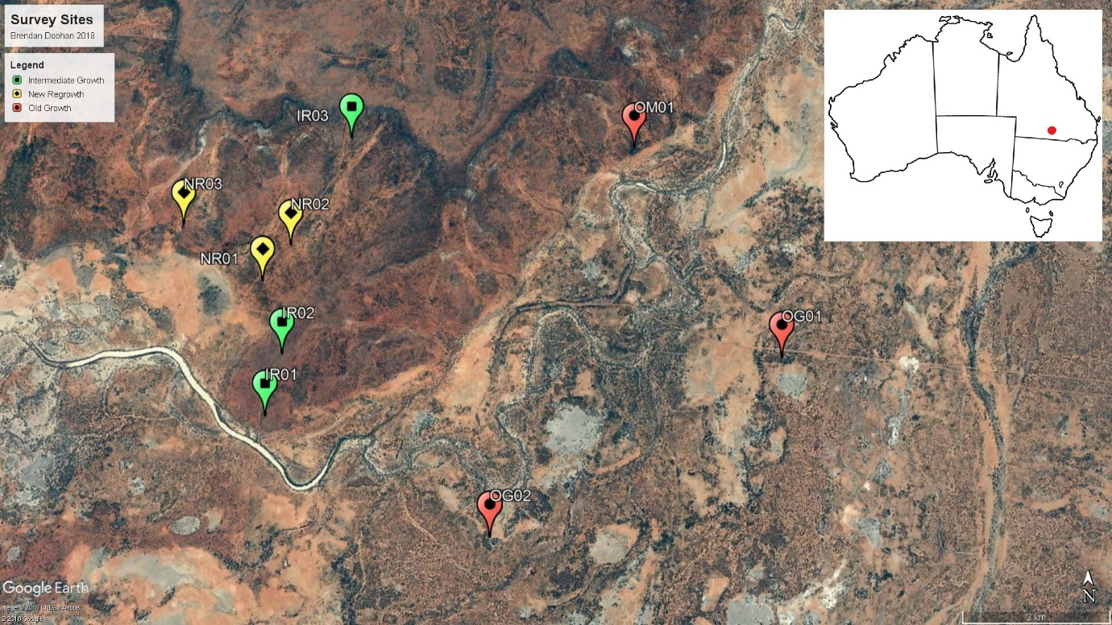

Figure 1: Site map. Yellow pins represent new regrowth sites, green pins represent intermediate regrowth sites, and red pins represent old growth sites.

## *2.2 Acoustic recording*

At each site, one acoustic monitor (SM3; Wildlife Acoustics) was attached to a tree approximately 1.5m above ground level. Trees closest to the centre of the vegetation patch were selected to minimise edge effects. A single microphone was attached to each monitor using a 2m extension lead and positioned away from open areas to minimise the impact of wind on the recordings. The monitors were programmed to record the dawn chorus (from sunrise; varying from 6:35am on the 29th of August to 6:04am on the 25th of September) continuously for three hours as determined by the sunrise times at the GPS coordinates of the property for 28 days (29th August 2017 – 25th September 2017). Files were recorded in mono at a sample rate of 22,050 Hz, with gain set to default. Recordings were stored as WAV files. This resulted in a total of 810 hours of recordings over the 28 day recording period.

A stratified hierarchical approach was used to sample the acoustic files to reduce the impact of autocorrelation. Each dawn recording was divided into one hour segments before a random number generator was used to select a total of 20 one minute files (6.6 files per hour) as per Wimmer et al., (2013). These same numbers were applied to each day processed and represented the *i-*th minute from dawn (i.e. the 10th minute sampled on the 29th of August was 7:57am, while the 10th minute sampled on the 25th of September was 7:26am). This off-set was programmed into the recordings to be representative of the true dawn chorus, as sunrise from the beginning to end of the surveying period varied by 31 minutes (Sunrise 29th August: 6:35am, Sunrise 25th September: 6:04am). The days chosen for analysis were selected in a similar fashion, with the total number of days divided by two and an even number of sample days randomly selected from each half via random number generation. An additional random day was added to reach the total number of sample days of 15. All files were listened to prior to analysis to determine their suitability for use. Days which had disturbances (e.g. rain) across all sites were removed from the analysis, and the next nearest un-sampled day was used. In total 45 hours of audio were processed. Species accumulation curves were used to justify the suitability of a 15 day sampling period for subsequent analysis.

All species were manually identified from their calls by one researcher and annotated on the Ecosounds website (<https://www.ecosounds.org/> project “Cunnamulla”). The location of the study is a well-established birding reserve and as such there are comprehensive lists of species which have been recorded on the property. A reference call catalogue of these known species was created and used to identify unknown calls. Additional species which were deemed to have the potential to exist on the site, due to geographic proximity or potential habitat cross over, were also added. The first call of each species per minute was annotated, resulting in a total number of species per minute. All files were checked twice at different stages of analysis to ensure that annotations were correct and that calling species were not missed through masking effects of wind, engines or other species calls.

## *2.3 Vegetation assessment*

Vegetation assessments were undertaken in March 2018 using the line intercept method (Canfield, 1941) with the aim of describing the dominant tree and shrub layers. The dominant tree layer was defined as all trees greater than 5m in height, while the dominant shrub layer was all shrubs between 1-3m in height. The 3-5m height stratum was excluded as it represented a mix of shrubs and saplings. At each site, two 50 metre transects were laid out and tree and shrub cover were estimated as a proportion of the total distance of the tape measure they covered. The height of the trees and shrubs which contributed to these cover estimates were also measured, along with the diameter at breast height of the trees. Five 1x1m quadrats were placed along each transect and percentage ground cover (litter, bare, rock, tree, shrub) was estimated. Due to a clerical error, shrub cover for one site (IR01) was not recorded. At all sites the dominant tree and shrubs were identified to species level, and it was noted if they were flowering at the time of the sensor deployment.

## *2.4 Data analysis*

All species identified were incorporated into site-specific species lists to enable calculation of species richness.

### *2.4.1 Functional Diversity*

A functional diversity matrix was created using the site-specific species lists and additional data related to the following functional traits: primary food type, foraging height, log10 average adult size (cm), and relative abundance. Primary food type was used as a proxy for feeding guild. Species were assigned one of the following primary food types; invertebrates, nectar, seeds, carrion, small vertebrates (small lizards, mammals, birds, etc), or fruits. Information relating to species primary food type was characterised from literature (Barker and Vestjens, 1990; Menkhorst et al., 2017; Morcombe, 2003). Where a species was considered an omnivore, the most abundant food source was selected. Foraging height was obtained from literature and species were assigned a value between 1 and 5. Species which feed exclusively on the ground received a score of 1, while species which were foraging generalists (take food from any strata) or required no vegetation to hunt their prey (exclusively aerial predators) were given a score of 5. Scores of 2 were for low vegetation and shrub layer foragers, scores of 3 represented trunk and mid canopy foragers, and scores of 4 were given to upper canopy foragers. Species were scored according to the maximum height at which they forage. For example, species which require low perching to pounce on prey were given a score of 2 (shrub and low vegetation). The average size of each species was obtained from field guides and other literature sources. While there are cases of sexual dimorphism in the size of different sexes in some bird species (e.g. birds of prey), these were pooled together as the sex of some bird species can be difficult to determine from their calls. A five scale categorical approach to abundance was implemented (rare – 1, very common – 5). This scale was informed by the total number of dawn choruses that the species was present in throughout the surveying period. Species were classified as very common if they were detected in greater than 70% of the sampled dawn choruses, common if present in 50-69%, fairly common if present in 25%-49%, uncommon if present in 10%-24%, and rare if present in less than 10% of sampled dawn choruses. Petchey’s FD (Petchey and Gaston, 2002) was selected as the metric of functional diversity due to the presence/absence nature of the data set (Flynn et al., 2009) and was calculated using R statistical software (R Core team, 2013).

### *2.4.2 Statistical Analysis*

All vegetation and species count variables were tested for normality and homogeneity before analysis. Univariate analyses were performed with analysis of variance (ANOVA) when examining variation between age classes. Non-parametric tests were used when data violated normality. Generalised linear models (GLMs) were used to explore the relationship between changes in diversity metrics (species richness and functional diversity) and vegetation attributes. The average of all vegetation attributes were taken at each site. When examining relationships with species diversity, a Poisson distribution was used as the data consisted of integer counts (Bowen et al., 2009). These models were tested for significance using a chi-squared frequency test. When examining relationships with functional diversity, a Gaussian distribution was used because the data was continuous. These models were tested using an F distribution. All GLMs were run with all variables (excluding shrub cover) and all sites included. Modelling was then repeated with all variables, excluding the site IR02 so that the effect of shrub cover could be explored. The model fits were calculated by taking the inverse of the null residual divided by the expected residual. The AIC values of each model was compared, with the lowest selected as the most appropriate model. Multi-variate models were not explored due to the outcomes of univariate results. Generalised linear mixed effects models were also performed, but as their model fits were poorer than those provided by GLMs they are not reported here. All statistical analyses were performed in R statistical software.

### *2.4.3 Species Assemblages*

Variation in species assemblages was examined based on the presence or absence of species across sites. Species associated with an age class (NR, IR, OG) were identified based on whether they were present at two or more sites of the same age class. If a species was present in two age classes, it was deemed associated to them both if it was detected at two sites in each age class. Species which were found in all age classes were classified as “not associated”.

A cluster analysis was used to examine species assemblages across sites. A presence/absence matrix was created using the site-specific species lists. Due to the binary nature of the dataset (Krebs, 1989), a Bray-Curtis distance measure was implemented using the package “vegan”. A distance dendrogram was then generated in R statistical software using the package “pvclust”. The clusters were determined using the average clustering method implemented by the “stats” package.

# 3. Results

## *3.1 Species Richness*

A total of 2700 minutes of acoustic data were processed from 15 days of recording, across nine sites. This resulted in 7022 annotations, representing an average of 2.6 calls per minute. In total, 66 species were detected over the survey period (appendix A). Species accumulation curves showed that 15 days of sampling was appropriate for the study; curves flattened at between ten to fourteen days for all sites (appendix B).

Species richness statistically differed across age classes (ANOVA: F value = 7.022, df = 2, p value = 0.02, figure 2). Species richness in old growth was highest (mean 46.5), followed by intermediate regrowth (mean 37.33), and new regrowth (mean 33.33). The site which recorded the highest total number of species was OG01, with a total of 50 species, or 75% of the total species detected. NR01 recorded the lowest total number (29), representing 43% of the total species. The results of the Tukey’s *post hoc* test showed that old growth and new regrowth were the most distinct age classes (difference = 13.333, p value = 0.02), while the other combinations were not statistically different (p value > 0.05).

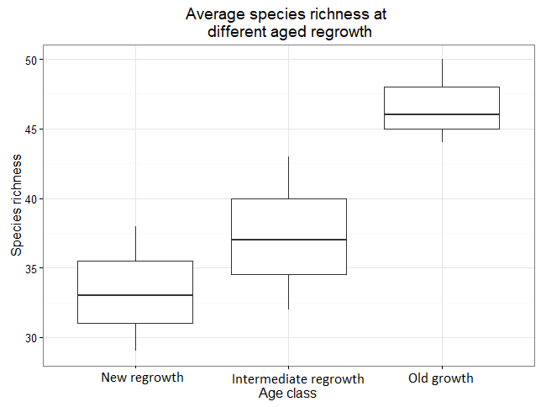

Figure 2: Average species richness of birds identified from acoustic recordings across age classes. Horizontal bars represent the median value, while the box represents the first and third quartile. The whiskers show the range of the data.

## *3.2 Functional diversity*

The functional diversity matrix consisted of 66 species (appendix C). When partitioned by dominant food source the species represented 34 insectivores (primarily food invertebrate), 12 granivores (seed), six carnivores (small vertebrates), one nectarivores (nectar), one scavengers (carrion), and one frugivore (fruit). Eleven omnivores were detected yet were classified as insectivores (five), nectarivores (five), or scavenger (one) for analysis based on their most likely food source. Eight of these omnivores were honeyeaters, two were generalist predators (Australian magpie, grey shrike-thrush), and one was a generalist scavenger (little crow). Twenty-two species were classified as ground foraging specialist, 10 as shrub foraging and below, nine as mid tree and below, 13 as canopy specialists and below, and 12 as aerial and below. According to their relative abundance at dawn, four species were classified as very common, seven were classified as common, 15 were classified as fairly common, 17 were classified as uncommon, and 23 were classified as rare. The average bird species length varied from 9.5cm (chestnut-rumped, and yellow thornbills) to 55cm (whistling kite).

Functional diversity was statistically different across age classes (ANOVA: F value = 6.211, df = 2, p value = 0.03; figure 3). Old growth had the highest FD score (mean 11.99), followed by intermediate regrowth (mean 10.14) and then new regrowth (mean 9.55). The highest FD score was recorded at OG01 (12.39), whilst the lowest was recorded at NR01 (8.63). The results of a Tukey’s *post hoc* test showed that old growth and regrowth were the most distinct age classes (difference = 2.441, p value = 0.03), while the other combinations were not statistically different (p value >0.05).

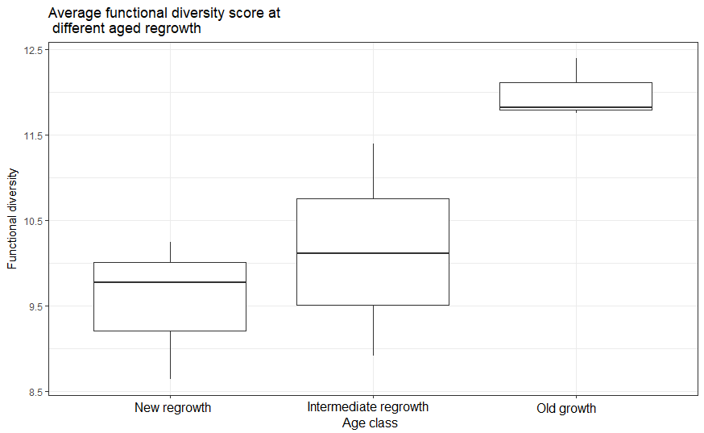

Figure 3: Average functional diversity (FD) score of bird assemblages across age classes. Horizontal bars represent the median value, while the box represents the first and third quartile. The whiskers show the range of the data.

## *3.3 Relationships between diversity measures and vegetation attributes*

The results of the generalised linear models for both species richness and functional diversity showed that tree cover was a moderate predictor for both measures. In both cases there was a positive correlation between increased tree cover and diversity measure. The model fit was higher when predicting functional diversity than it was for species richness. All other vegetation variables were not statistically significant (table 2). GLM’s were created again with IR02 excluded to examine the effects of shrub cover on species richness and functional diversity. Once again, only tree cover remained a significant predictor of both functional diversity and species richness (table 2).

Table 2: Relationships between species richness (SR) and functional diversity (FD) vegetation variables. * indicates analysis that were re-run with IR02 removed.

|  |  |  |  |  |  |  |  |  |
| --- | --- | --- | --- | --- | --- | --- | --- | --- |
| Independent | Dependent | Model Fit | DF | AIC | Dependent | Model Fit | DF | AIC |
| Tree cover | SR | 0.478 | 2 | 58.818 | FD | 0.438 | 3 | 30.603 |
| DBH | SR | 0.353 | 2 | 60.110 | FD | 0.357 | 3 | 31.816 |
| Tree height | SR | 0.292 | 2 | 60.734 | FD | 0.299 | 3 | 32.590 |
| Shrub height | SR | 0.005 | 2 | 63.694 | FD | 0.001 | 3 | 35.788 |
| Ground cover | | | | | | | | |
| Rock | SR | 0.120 | 2 | 62.507 | FD | 0.170 | 3 | 34.114 |
| Litter | SR | 0.096 | 2 | 62.753 | FD | 0.187 | 3 | 33.928 |
| Shrub | SR | 0.013 | 2 | 63.6137 | FD | 0.001 | 3 | 35.782 |
| Tree | SR | 0.001 | 2 | 63.741 | FD | 0.032 | 3 | 35.496 |
| Bare | SR | 0.001 | 2 | 63.745 | FD | 0.004 | 3 | 35.758 |
| IR02 removed | | | | | | | | |
| Tree cover* | SR | 0.629 | 2 | 51.95421 | FD | 0.575 | 3 | 24.672 |
| Shrub cover* | SR | 0.052 | 2 | 56.43762 | FD | 0.064 | 3 | 30.986 |

## *3.4 Species Assemblages*

The cluster analysis revealed three distinct clusters with sites grouped according to age class (figure 4). New regrowth sites were most dissimilar to intermediate and old growth sites and intermediate regrowth sites were more similar to old growth sites than new regrowth sites. Within the old growth age class, the two sites dominated by *A. cambagei* grouped together, while the old growth site dominated by *A. anuera* was dissimilar but still within the same cluster.

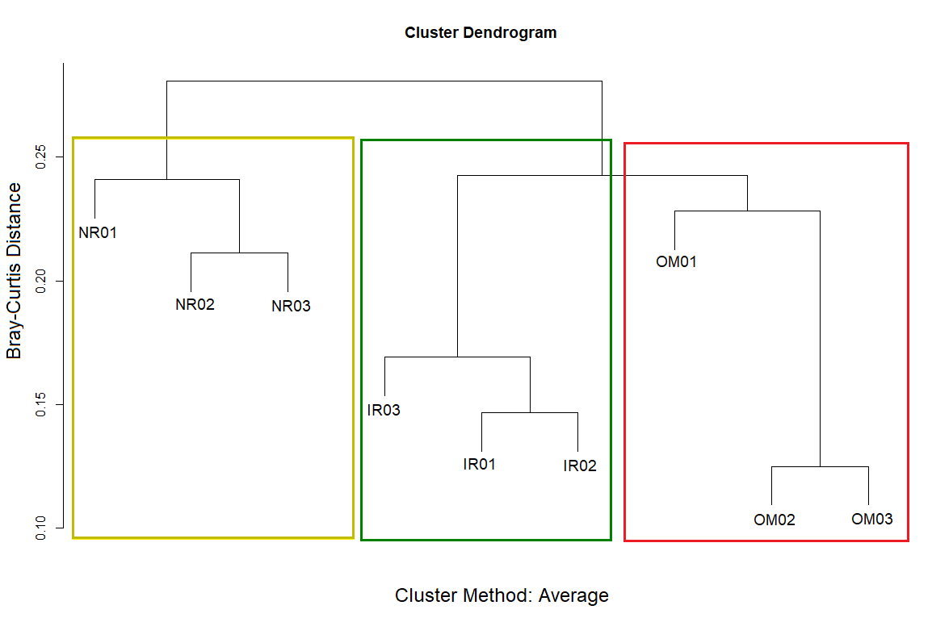

Figure 4: Cluster analysis of bird species composition (presence or absence) across all sites. The boxes delimit the clusters, with the colours representative of age class (yellow=new regrowth, green =intermediate regrowth, red=old growth).

Several species were associated with one or two different age classes (table 1). New regrowth and intermediate regrowth had two associated species each. Old growth had three age class associated species. All three species were shared exclusively between the sites dominated by *A. cambagei*. New regrowth and old growth shared two associated species, while new regrowth and intermediate regrowth did not share any species. Old growth and intermediate regrowth shared the highest number of associated species (three). Thirty species (45% of the total species count) were found in more than one age class but were not associated with both (found in less than two sites per age class). Four of these species were highly associated with one age class (present at greater than two sites per age class) and were present at only one site of another age class. Twenty-three species (35% of the total species count) were found at six or more sites across all age classes and showed no association.

Table 1: Species associated with different age classes. Associated refers to species detected at two or more sites in an age class. Where a species was associated to one site but present at another without being associated, the dominant age class was described first (i.e. old growth dominant but present in intermediate regrowth is displayed as Old~Int). Species were classified as no association if they were found at six or more sites across all age classes.

|  |  |  |
| --- | --- | --- |
| Associated Species – Single AGE CLASS | species Common name | Scientific name |
| NEW Regrowth | Rufous Songlark | *Megalurus mathewsi* |
|  | Welcome Swallow | *Hirundo neoxena* |
| Intermediate | Fan-tailed Cuckoo | *Cacomantis flabelliformis* |
|  | Red-rumped Parrot | *Psephotus haematonotus* |
| Old Growth | Shining Bronze-Cuckoo | *Chalcites lucidus* |
|  | White-winged Chough | *Corcorax melanorhamphos* |
|  | White-winged Fairywren | *Malurus leucopterus* |
| ASSOCIATED SPECIES – TWO age classes |  |  |
| NEW Regrowth and Intermediate | Nil |  |
| Intermediate and Old growth | Brown Treecreeper Mistletoebird | *Climacteris picumnus*  *Dicaeum hirundinaceum* |
|  | Red-browed Pardalote | *Pardalotus rubricatus* |
| NEW Regrowth and Old growth | Brown Honeyeater  Yellow-rumped Thornbill | *Lichmera indistincta*  *Acanthiza chrysorrhoa* |
| Associated to one BUT present in a second | Chestnut-breasted Quail-thrush (Old~Int) | *Cinclosoma castaneothorax* |
| Pallid Cuckoo (Old~Int) | *Cacomantis pallidus* |
|  | Rainbow Bee-eater (Old~Int) | *Merops ornatus* |
|  | White-plumed Honeyeater (Old~New) | *Ptilotula penicillata* |
| No Association (All age classes) | Australian Magpie  Australian Raven | *Gymnorhina tibicen*  *Corvus coronoides* |
|  | Australian Ringneck | *Barnardius zonarius* |
|  | Bar-shouldered Dove | *Geopelia humeralis* |
|  | Chestnut-rumped Thornbill | *Acanthiza uropygialis* |
|  | Crested Bellbird | *Oreoica gutturalis* |
|  | Crested Pigeon | *Ocyphaps lophotes* |
|  | Grey Butcherbird | *Cracticus torquatus* |
|  | Grey Shrike-thrush | *Colluricincla harmonica* |
|  | Horsfield's Bronze-Cuckoo  Inland Thornbill  Major Mitchell's Cockatoo  Masked Woodswallow | *Chrysococcyx basalis*  *Acanthiza apicalis*  *Lophochroa leadbeateri*  *Artamus personatus* |
|  | Noisy Friarbird | *Philemon corniculatus* |
|  | Peaceful Dove | *Geopelia placida* |
|  | Pied Butcherbird | *Cracticus nigrogularis* |
|  | Red-winged Parrot | *Aprosmictus erythropterus* |
|  | Rufous Whistler | *Pachycephala rufiventris* |
|  | Singing Honeyeater | *Gavicalis virescens* |
|  | Spiny-cheeked Honeyeater  Splendid Fairywren | *Acanthagenys rufogularis*  *Malurus splendens* |
|  | Willie Wagtail | *Rhipidura leucophrys* |
|  | Yellow-throated Miner | *Manorina flavigula* |

# 4. Discussion

Results of this study have shown that a range of bird species utilise regrowth vegetation in the Mulga Lands bioregion. Our results reveal that avian biodiversity is greatest in old growth and least in new regrowth. Importantly, avian biodiversity in intermediate regrowth was not statistically different to that found in old growth woodlands. It is likely that regrowth of varying ages provides different resources, and as such influences the bird assemblages likely to be found in them. This study highlights the important biodiversity value of regrowth vegetation in semi-arid eastern Australia.

## *4.1 Bird diversity response to different aged regrowth*

*Species Richness*

The increase in avian species richness found in our study in the time since vegetation clearance is reflective of results reported in other regrowth studies (Berry, Lindenmayer and Driscoll, 2015; Bowen et al., 2009). Of note, however, was our finding that species richness in intermediate regrowth was not statistically different to old growth. As old vegetation patches have had more time to recover from disturbance than new regrowth, these sites are able to provide a wider variety of resources that different species can exploit (Williams et al., 2001). This has been observed in vegetation regrowing from natural disturbance (i.e. fire) and anthropogenic disturbance (i.e. clearing and grazing; Berry, Lindenmayer and Driscoll, 2015; Bowen et al., 2009; Leavesley et al., 2010). In these cases, the returning species are relying on the development of critical resources, some of which can take a significant amount of time to return. For example, Berry, Lindenmayer and Driscoll, (2015) found that species richness varied in age since time burnt, and commented that certain bird species did not return to regrowth sites for decades after disturbance as resources were absent. This was also observed in regrowth *Acacia* shrubland recovering from fire in central Australia (Leavesley et al., 2010). Even in productive ecosystems such as temperate woodlands, woodland bird species richness can take more the 15 years before showing signs of recovery following intensive logging, although within 22 years bird species richness approached parity (Kavanagh and Stanton, 2003). This is reflective of our study where, despite disturbance being halted at the study location, species richness significantly varied across sites as they recovered from vegetation clearance.

Many recent studies have reported the value of maintaining structural features of old vegetation stands, particularly when considering avian diversity, as they remain critical for foraging (e.g. coarse woody debris) and breeding (e.g. tree hollows) and are often absent from young stands of vegetation (Bowen et al., 2007; Koch, Munks and Spencer., 2009; Loyn and Kennedy, 2009; Mac Nally et al., 2001). Bird species can exploit a wide variety of resources depending on their foraging habits and their niche requirements (Antos, Bennett and White, 2008; Bennett et al., 2015). For example, ground foraging specialists can use a variety of different substrates to forage in, so much so that some authors recommend partitioning these feeding guilds into strata favouring species (Antos, Bennett and White, 2008). Layers of leaf litter and coarse woody debris are beneficial for many ground foraging species as they can provide substrates to probe for invertebrates or to ambush and pounce on prey (Antos and Bennett, 2006; Antos, Bennett and White, 2008). These features, particularly large quantities of coarse woody debris, are likely to be absent from areas which have been extensively cleared and grazed (Manning, Cunningham and Lindenmayer, 2013; Yates et al., 2000). Species which rely on canopy cover to feed are also unlikely to be present in regrowth vegetation as appropriate foraging substrates have not yet developed (Bowen et al., 2009). In our study, the new regrowth lacked tree cover in comparison to the intermediate and old growth sites and it was predicted that the new regrowth would be inappropriate for canopy cover reliant species. However this was not the case, with the regrowth providing habitat for numerous species such as thornbills, splendid fairywrens, and a variety of honeyeaters.

Plant phenology also has an impact on avian species assemblages (Burbidge and Fuller, 2007; Ford and Paton, 1976; Keast, 1967). In our study, the flowering of plants is likely to have increased species richness at the old mulga site due to of the presence of a prolifically flowering *Corymbia terminalis*, and at the regrowth sites where *Acacia victoriae* were flowering at the time of the acoustic survey. Species which are semi-reliant on flowering (brown honeyeater) were only found at sites where flowering was occurring. This may have supplemented species richness at sites which were otherwise unlikely to attract these species due to the immaturity of mulga regrowth (Keast, 1967). Nevertheless, *A. victoriae* and *C. terminalis* most commonly flower during the spring (Friedel et al., 1994), and as such any increase in species richness in response to the flowering of these plants is reflective of spring avifauna assemblages*.* Bird species are known to travel significant distances to obtain resources and have been recorded to supplement their diets with resources provided exclusively by regrowth vegetation. Regrowth understory plants can provide resources, such as nectar and fruits, which developing adult trees cannot yet provide due to sexual immaturity (Blake and Loiselle, 2001; Bowen et al., 2007). Old growth associated species such as male Victoria’s riflebirds (*Ptiloris victoriae*) have been observed exploiting regrowth vegetation for fruit when resources in adjacent old growth forests become scarce (Grant and Litchfield, 2003). This is relevant when considering highly mobile bird species of the semi-arid zone, such as the brown honeyeater, which are likely to move into sites when appropriate resources become present. Nevertheless, some studies suggest that while resource tracking may be important for maintaining species richness, vegetation variables are more significant predictors (Pavey and Nano, 2009). In our study, species richness may have periodically increased due to seasonal resource abundance, but was probably not outside the realms of normality, and thus cannot be discredited.

Highly mobile species are also likely to have inflated the species richness of sites. Australian ravens, Major Mitchell’s cockatoos, masked woodswallows, red-winged parrots, and whistling kites were detected at more than seven sites, yet for the majority of these cases it is unlikely that they were reliant on the resources at these sites. For example, Major Mitchell’s cockatoos are known to have large home ranges and feed primarily on *Callitris columellaris*seeds (Menkhorst et al., 2017) which were not present at any of our survey sites. Only at one site (OM01) were Major Mitchell’s cockatoos observed to be foraging (pers. obs.). It is likely that flocks were moving between locations to roost and feed. This was similarly the case with red-winged parrots which, while more generalist feeders than Major Mitchell’s cockatoos, were only observed feeding at one site (OM01). This species is also known to travel some distance to acquire appropriate food and is partially nomadic (Menkhorst et al., 2017). Australian ravens, while showing some territorial behaviour, are generalist scavengers and are known to travel large distances in search of resources (Menkhorst et al., 2017). As they feed primarily on the ground, they are less likely to be associated with sites due to vegetation features, but rather by the presence or absence of appropriate food, and are thus habitat generalists (Menkhorst et al., 2017). Whistling kites behave similarly (Fuentes, Olsen and Rose, 2005) and while a nesting whistling kite was observed within one kilometre of OM01, it is unlikely that this species was restricted to this area as they are capable of foraging over significant distances when required. Masked woodswallows were recorded at all sites, but this is likely to have been the result of a troop of birds flying overhead hawking insects. Furthermore, the species are highly migratory and are unlikely to be present at any sites in future months (Tischler and Dickman, 2013).

*Functional diversity*

The functional diversity results were in close agreement with those found for species richness, including the finding that intermediate regrowth was not statistically different from old growth. These results are consistent with other studies examining avian functional diversity response to intensity of land use, where functional diversity is lower in less structurally complex sites (Flynn et al., 2009; Sayar, Bullock and Martin, 2017). However, the species which contribute to functional diversity in these regenerating sites are often represented by one or two abundant feeding guilds which can capitalize on the resources of these sites. A meta-analysis by Flynn et al., (2009) found that small ground feeding granivores and shrub feeding nectarivores of tropical and temperate forests were more likely to be present and abundant in agricultural land than species which have different foraging and food requirements. Our study reflected similar trends, with ground feeding granivores and insectivores present at all sites suggesting that the resources required to sustain these feeding groups are present across all age classes. This is unsurprising as ground foraging birds, particularly insectivores, are highly abundant in arid and semi-arid zones and can exploit more terrain than those which require canopy substrates to forage (Burbidge et al., 2012; Recher and Davis, 1997; Tischler and Dickman, 2013). Nevertheless, studies have also suggested that increased functional diversity is not reliant on increased species richness alone, and that other factors can be influential (Luck, Carter and Smallbone, 2013).

Rare species, and species which fill novel ecological roles, have been reported to have more significant impacts on functional diversity than common species (Luck, Carter and Smallbone, 2013; Seymour et al., 2015). This is the case in our study where species which foraged in the canopy or represented rare feeding specialists (frugivores) were only detected in old growth and intermediate regrowth. Species which meet the criteria of “rare” or “novel feeders” exploit resources which others do not or cannot, and by association provide functional roles which are not otherwise provided (Flynn et al., 2009). These species are also reliant on the presence of appropriate resources at sites, and their absence can indicate a poorly functioning ecosystem. It is therefore unsurprising that our results revealed increasing functional diversity in sites which were more structurally complex, as these habitats have more resources and niches which rare species can exploit. This has been observed in arid studies undertaken across latitudinal gradients, where functional diversity increases with vegetation structure and rainfall (Seymour et al., 2015).

Some studies on functional diversity of birds in regrowth vegetation have found that there is less redundancy in younger regrowth, and while this was not explored in our study, it can be inferred by the dominance of ground foraging granivores and insectivores. Increased functional redundancy is beneficial to ecosystem services as it provides stability, and reduces the impact of the loss of an individual species on overall ecosystem function. Sites which can provide resources for functionally similar species are therefore more likely to have overlap in ecological roles. As such, it is not unexpected that high functional redundancy will be found in undisturbed sites with complex habitat structure. Sayar, Bullock and Martin, (2017) found that secondary regrowth rainforest had lower functional redundancy than primary forest, although it increased to similar levels within 22 years of regeneration. This suggests that increasing structural complexity in vegetation features may allow for more redundancy in ecological roles. Similarly, Seymour et al., (2015) found that changes in arid vegetation (open savanna to riparian woodland), along with increasing rainfall, were a strong predicator of functional diversity and also functional redundancy. While our study sites differed in vegetation structure across age classes, the results followed a similar trend. Furthermore, certain functional groups, such as insectivores, are more likely to show functional redundancy than others (Luck, Carter and Smallbone, 2013). Our study found that intermediate regrowth and old growth sites supported more insectivorous species, and it can be inferred that they have similar ecological roles, thus providing increased functional redundancy in older sites. Few studies have examined avian functional diversity in arid or semi-arid zones (although see Seymour et al., 2015), rather using functional group responses to vegetation and rainfall (Tischler and Dickman, 2013). As such our functional diversity results offer novel insight into bird assemblages in the semi-arid zone.

*Vegetation attributes*

Vegetation structural attributes have been consistently linked to increased bird species richness and functional diversity (Hannah et al., 2007; Kavanagh and Stanton, 2003; Seymour et al., 2015). We also identified a relationship with the results of the generalised linear models showing high model fits for tree cover and species richness and functional diversity. Increased tree cover provides roosting and nesting sites, increased leaf litter levels and invertebrate abundance, and these features are critical to the insectivorous bird fauna of the Mulga Lands (Bowen et al., 2009; Cody, 1994; Recher and Davis, 1997). Increased canopy cover in old growth provides more foraging opportunities for canopy feeding species relative to newer and intermediate regrowth. Similar results have been found in temperate and tropical forests (Bowen et al., 2009; Smallbone, Matthews and Lunt, 2014; Tassiker et al., 2006). Tree diameter at breast height (DBH) and tree height had lower model fits, but this is likely due to the presence of emergent *Eucalyptus populnea* trees in new regrowth sites. Nevertheless, other studies have shown that DBH and tree height are important for bird species, particularly for roosting and foraging (Woinarski et al., 2010). For example, Antos, Bennett and White, (2008) found that bird species that rely on large DBH trees for probing and gleaning insects (such as treecreepers) are not found in young regrowth. This is consistent with our study, where brown treecreepers were only found at sites with large girth trees.

Our study did not identify any relationship between shrub cover or shrub height and species richness and functional diversity*.* Shrub cover varied little across age classes, although was lowest in intermediate regrowth and highest in new regrowth. Certain bird species which either avoid dense shrub layers or require high foraging strata would be less abundant in new regrowth. Shrub cover has been found to be negatively correlated with ground foraging bird species, such as jacky winter (Antos, Bennett and White, 2008). Average shrub height of the dominant shrub layer was also found in our study to vary very little, irrespective of shrub species composition. The new regrowth consisted of a mixture of young *Acacia* species, while the old growth had a shrub layer dominated by *Eremophila* species; all two to three metres in height. While shrubs may represent important foraging habitat for some species, overall bird species richness and functional diversity was not linked to shrub structural attributes in the Mulga Lands birds, and this is contrary to what has been observed in other environments (Bennett et al., 2015).

Species richness and functional diversity were also not related to any ground cover attributes. This is at odds with several studies which note the importance of ground cover, particularly for ground foraging birds (Antos and Bennett, 2006; Montague-Drake, Lindenmayer and Cunningham, 2009; Recher and Davis, 1997). In temperate environments, leaf litter has been shown to be a good predictor of bird species richness (Antos and Bennett, 2006). In our study, the lack of relationship between leaf litter cover and species richness and functional diversity is likely due to the fact that ground cover was very low and varied little across age classes. In dry environments, it is not only the quantity but also the quality of the litter which can drive increased arthropod abundance (Noble, Whitford and Kaliszweski, 1996; Smallbone, Matthews and Lunt, 2014; Taylor, 2008). Features such as soil moisture retention and depth of leaf litter are critical, but unfortunately were not measured in our study.

It is likely that our results were also influenced by climatic conditions during the survey period. The acoustic survey was undertaken just after a period of slightly higher monthly rainfall, albeit just a few millimetres. However, the vegetation survey was undertaken six months later, and it did not rain during the time intervening. As such, ground cover estimates may not be representative of those during the acoustic recording period. Desert flora respond quickly to sporadic rainfall events (Schwinning and Sala, 2004; Wright and Zuur, 2014), and may have provided extra resources during the recording period. Desert plants are quick to seed (Noy-Meir, 1973; Wright and Zuur, 2014) and this may have explained the high level of granivores at some sites. Furthermore, bird species use different types of ground vegetation for foraging (seeding grasses or forbs and tubers) depending on their biological requirements, yet our study design did not differentiate ground vegetation types (Antos and Bennett, 2006; Heinsohn, 1991). For example, Antos and Bennett, (2006) found that diamond firetails (*Stagonopleura guttata*) preferred to forage on bare ground and grasses rather than substrates like leaf litter. Coarse woody debris is also a beneficial substrate for ground foraging insectivores as it allows insectivores to launch pouncing attacks, while simultaneously retaining moisture and increasing arthropod abundance (Antos, Bennett and White, 2008; Goldin and Hutchinson, 2014). While there was visually more coarse woody debris at different sites (particularly at the intermediate sites), this was not measured in our study and inferences about the role of coarse woody debris in predicting species richness and functional diversity cannot be ascertained.

*Species composition*

The cluster analysis of species composition showed clear grouping of sites according to age class. While there were many common species which were found at the majority of sites regardless of age class, more than half of the species were found at only one or two age classes. This is not surprising; like species richness, bird species composition will change in response to the availability of resources at a site (Leavesley et al., 2010) and these variations are likely to have been key drivers of functional diversity. Interestingly, intermediate regrowth and old growth shared the highest number of species between age classes, suggesting that intermediate regrowth is approaching a similar species composition to old growth sites.

Species associated with a single age class appear to rely on vegetation attributes for foraging requirements which were only found at certain stages of regrowth. Species found exclusively in the old growth *A. cambagei* dominated sites were all predominately insectivorous and likely benefited from increased canopy cover. Canopy cover can increase soil moisture and nutrient retention, insect abundance and leaf litter (Entling et al., 2007; Levings and Windsor, 1984; Ludwig and Tongway, 1995; Tongway and Ludwig, 1996) which is beneficial for ground foraging probing (white-winged chough; Beck and Heinsohn, 2006; Heinsohn, 1991) and gleaning species (white-winged fairywren; Pruett-Jones and Tarvin, 2001), while simultaneously providing canopy substrates for leaf gleaning species (shining bronze-cuckoos; Morcombe, 2003). Species found exclusively at intermediate sites likely benefited from lower perching branches for ambushing prey (fan-tailed cuckoo; Holmes and Recher, 1986) or open understory for predator vigilance (red-rumped parrot; Lowry and Lill, 2008; Selwood, Mac Nally and Thomson, 2009), as these were common structural features of intermediate regrowth. Species detected exclusively in new regrowth were open landscape specialists which do not require trees or shrubs in which to forage (Menkhorst et al., 2017). It is not uncommon for new regrowth to support open landscape specialists, particularly as these species are more likely to be able to exploit resources without requiring vegetation to regenerate (Berry, Lindenmayer and Driscoll, 2015, Kavanagh and Stanton, 2003; Leavesley et al., 2010).

Species associated with two age classes, and species associated to one age class but present in another, were also reliant on vegetation attributes which were present in multiple stages of regrowth. The species detected in both old and intermediate regrowth forage on tree attributes which were not present in new regrowth. These species feed on fruits (mistletoebird; Bowen et al., 2009; Ward and Paton, 2007), glean insects from foliage in the canopy (red-browed pardalote; Tischler and Dickman, 2013), launch aerial or ground ambushes from branches (rainbow bee-eater,and pallid cuckoo; Recher and Davis, 1997; Recher and Davis 2010), or probe insects from tree trunks (brown treecreeper; Antos, Bennett and White, 2008; Menkhorst, et al., 2017). One species (chestnut-breasted quail-thrush) was probably not influenced by the vegetation structure of old and intermediate sites despite its association with these age classes, rather the presence or absence of appropriate rock substrates for foraging (Tischler and Dickman, 2013) Species associated with both old and new regrowth were likely to be foraging in these sites in response to the increased resources associated with the flowering of *A. victoriae* (brown honeyeater, and white-plumed honeyeater; Fischer and Lindenmayer, 2002; Menkhorst et al., 2017; Selwood, Mac Nally and Thomson, 2009) or shrubs required for cover (yellow-rumped thornbills; Menkhorst et al., 2017). Interestingly, no species were associated with both intermediate and new regrowth, although this is likely in response to the regeneration of *A. aneura* which transitions from shrub to tree, greatly changing the overall vegetation structure of the sites. Certain vegetation features (e.g. shrub layer or canopy cover) can be lacking in different stages of regrowth, as the regeneration process creates vegetation communities which are uniform in structure (Blakey et al., 2016). It is therefore possible that species where not shared between these age classes as they lack structural similarities.

Twenty three species were found across all age classes, however ten (rufous whistler, crested bellbird, grey shrike-thrush, spiny-cheeked honeyeater, splendid fairywren, chestnut-rumped thornbill, singing honeyeater, willie wagtail,Australian raven, and inland thornbill) have been previously noted as mulga associated species (Cody, 1994) and so their ability to utilize all forms of regrowth *A. aneura* vegetation is unsurprising. A further ten (Australian magpie, Australian ringneck, bar-shouldered dove, crested pigeon, grey butcherbird, pied butcherbird, noisy friarbird, red-winged parrot,yellow-throated miner, and masked woodswallow) are also relatively common to the Mulga Lands and another is common (Horsfield’s bronze cuckoo) to mulga dominated landscapes outside of the Mulga Lands (Cody, 1994; Recher and Davis 1997). Of the remaining two species, the Major Mitchell’s cockatoo is reliant on stands of *Callitris columellaris* for foraging (Morcombe, 2003), and the peaceful dove requires daily access to water (Menkhorst et al., 2017). Both of these requirements were present at Bowra, but may not have been present at the study sites of other similar studies (Cody, 1994; Leavesley et al., 2010).

The variation in species assemblages reflects the results of many previous studies; as time increases since the initial disturbance, species assemblages change in response to the changes in vegetation structure. Kavanagh and Stanton (2003) found that some species will take up to 15 years to return after logging, particularly if they feed in the canopy or on tree trunks. This is reflected in our study where species which rely on these structures became increasingly common as regrowth aged. In particular, a large number of woodland dependent species were associated with or becoming associated with intermediate regrowth and old growth, reflecting the importance of these age classes to many bird species. While four bird species (welcome swallow, rufous songlark, little friarbird, and spotted nightjar) were not detected in either old growth or intermediate regrowth, it is clear that the age of regenerating regrowth has a positive or neutral impact on the majority of bird species recorded during the study.

## *4.2 Implications for conservation*

This study has a number of implications for biodiversity conservation in the Mulga Lands bioregion. Firstly, regrowth *Acacia* that has regenerated over a relatively short period of time (15-30 years) since disturbance has a level of bird species richness and functional diversity that is becoming equivalent (statistically) to that recorded in old growth *Acacia* woodlands. While protection of old growth vegetation is critical for canopy foraging specialists (Bowen et al., 2009), many species which cannot use new regrowth are able to exploit intermediate aged *Acacia* woodlands. Protection of intermediate regrowth of 15 years and greater is thus recommended. Secondly, while not addressed in this study, regrowth vegetation may be an important tool in reconnecting patches of old remnant vegetation (Bowen et al., 2009). While intermediate regrowth was not utilised by all species found in the old growth, the proximity of this regrowth to old growth stands can increase species movement or, if adjoining old growth sites, decrease edge effects. Future research should examine the impact that landscape configuration has on bird assemblages in regrowth and remnant vegetation of the Mulga Lands, and other areas of semi-arid Australia.

## *4.3 Limitations*

One of the biggest limitations of our study was that it examined only two metrics of diversity. While species richness and functional diversity revealed similar patterns across age classes, it is unknown how phylogenetic diversity varies across different age classes of regrowth vegetation. Phylogenetically distinct species are of great conservation concern as these unique lineages are particularly vulnerable to extinction (Faith, 1992). These are often at the forefront of conservation campaigns and understanding how they utilize landscape elements is critical, particularly when considering the increasing lack of remnant vegetation available to these species. Our study also did not consider the effects of regrowth vegetation on regionally endemic species. While one species endemic to the Mulga Lands (Hall’s babbler) was present in this study, it was detected sporadically in all of our age classes, so we are unable to make conclusions about how it utilises different age classes of regrowth across its range. Many endemic species are of particular conservation concern due to their small home ranges and the effects of landscape modification on their remaining habitat (Purvis et al., 2000).

Furthermore, our study only focused on one group of bioindicators, and as such some of our results may not reflect the value of regrowth vegetation for other taxonomic groups (Tews et al., 2003). Reptiles have shown mixed responses to aging regrowth in the surrounding bioregions (Bruton et al., 2013; McAlpine et al., 2015; Michael, Cunningham and Lindenmayer, 2011) and other taxonomic groups (e.g. bats) have had negative relationships with regenerating forests due to the dense developing canopy and shrub layers (Blakey et al., 2016). Understanding how these taxonomic groups vary in their response to regrowth is critical for effective design of conservation initiatives. Future research should explore how regionally endemic and taxonomically distinct bird species, and other taxonomic groups utilise aging regrowth vegetation in the semi-arid zone of Australia.

# 5. Conclusion

Regrowth vegetation plays a critical role in preserving avian biodiversity in the Mulga Lands bioregion. All diversity metrics examined in this study increase as the time since disturbance passes, with intermediate regrowth (cleared within 15 to 30 years ago) rapidly approaching similar species richness, functional diversity and species composition to old growth sites. Tree cover was a significant predictor of species richness and functional diversity, explaining over half of the variation. While the results of this study show that old growth vegetation still preserves the highest levels of biodiversity amongst age classes, regrowth *Acacia* woodlands support a wide variety of species at different stages of regeneration. Therefore, it is a conservation priority that *Acacia* dominated regrowth vegetation in the semi-arid Mulga Lands is protected as it represents important habitat for avian biodiversity in the region.

# Acknowledgements

We would like to thank the Australian Wildlife Conservancy for site access, previous species records and facilitation of the project, Prof. Paul Roe for the loan of additional sensors, the administrators of the Ecosounds platform for access to the website, Dr. Ian Williamson for statistical advice, Karina Pyle for equipment assistance, Leah Gustafson for field assistance, and Francesca Strutt for feedback on the manuscript.

# References

Antos, M. J., Bennett, A. F. (2006). Foraging ecology of ground-feeding woodland birds in temperate woodlands of southern Australia. *Emu*, *106*(1), 29-40. Doi: 10.1071/mu05039

Antos, M. J., Bennett, A. F., White, J. G. (2008). Where exactly do ground-foraging woodland birds forage? Foraging sites and microhabitat selection in temperate woodlands of southern Australia. *Emu*, *108*(3), 201-211. Doi: 10.1071/mu08005

Barnosky, A. D., Matzke, N., Tomiya, S., Wogan, G.O., Swartz, B., Quental, T.B., Marshall, C., McGuire, J. L., Lindsey, E. L., Mersey, B., Ferrer, E. A., Maguire, K. C. (2011). Has the Earth’s sixth mass extinction already arrived? *Nature, 471*(7336), 51-57. Doi: 10.1038/nature09678

Barker, R. D., Vestjens, W. J. M. (1990). *The food of Australian birds 2. Passerines*. Clayton South, VIC: CSIRO Publishing.

Barrett, G. W., Ford, H. A., Recher, H. F. (1994). Conservation of woodland birds in a fragmented rural landscape. *Pac Conserv Biol*, *1*(3), 245-256. Doi: 10.1071/pc940245

Beck, N. R., Heinsohn, R. (2006). Group composition and reproductive success of cooperatively breeding white-winged choughs (*Corcorax melanorhamphos*) in urban and non-urban habitat. *Austral Ecol*, *31*(5), 588-596. Doi: 10.1111/j.1442-9993.2006.01589.x

Benayas, J. M. R., Bullock, J. M., Newton, A. C. (2008). Creating woodland islets to reconcile ecological restoration, conservation, and agricultural land use. *Front Ecol Environ*, *6*(6), 329-336. Doi: 10.1890/070057

Bennett, J. M., Clarke, R. H., Horrocks, G. F., Thomson, J. R., Mac Nally, R. (2015). Climate drying amplifies the effects of land-use change and interspecific interactions on birds. *Landscape Ecol*, *30*(10), 2031-2043. Doi: 10.1007/s10980-015-0229-x

Berry, L. E., Lindenmayer, D. B., Driscoll, D. A. (2015). Large unburnt areas, not small unburnt patches, are needed to conserve avian diversity in fire-prone landscapes. *J Appl Ecol*, *52*(2), 486-495. Doi: 10.1111/1365-2664.12387

Blake, J. G., Loiselle, B. A. (2001). Bird assemblages in second-growth and old-growth forests, Costa Rica: perspectives from mist nets and point counts. *Auk*, *118*(2), 304-326. Doi: 10.2307/4089793

Blakey, R. V., Law, B. S., Kingsford, R. T., Stoklosa, J., Tap, P., Williamson, K. (2016). Bat communities respond positively to large-scale thinning of forest regrowth. *J Appl Ecol*, *53*(6), 1694-1703. Doi: 10.1111/1365-2664.12691

Bowen, M. E., McAlpine, C. A., House, A. P., Smith, G. C. (2007). Regrowth forests on abandoned agricultural land: a review of their habitat values for recovering forest fauna. *Biol Conserv*, *140*(3-4), 273-296. Doi: 10.1016/j.biocon.2007.08.012

Bowen, M. E., McAlpine, C. A., Seabrook, L. M., House, A. P., Smith, G. C. (2009). The age and amount of regrowth forest in fragmented brigalow landscapes are both important for woodland dependent birds. *Biol Conserv*, *142*(12), 3051-3059. Doi:10.1016/j.bicon.2009.08..005

Bradshaw, C. J. (2012). Little left to lose: deforestation and forest degradation in Australia since European colonization. *J Plant Ecol*, *5*(1), 109-120. Doi: 10.1093/jpe/rtr038

Brown, S., Lugo, A. E. (1990). Tropical secondary forests. *J Trop Ecol*, *6*(1), 1-32. Doi: 10.1017/s0266467400003989

Bruton, M. J., McAlpine, C. A., Maron, M. (2013). Regrowth woodlands are valuable habitat for reptile communities. *Biol Conserv*, *165*, 95-103. Doi: 10.1016/j.biocon.2013.05.018

Burbidge, A. A., Fuller, P. J. (2007). Gibson Desert birds: responses to drought and plenty. *Emu*, *107*(2), 126-134. Doi: 10.1071/mu06044

Canfield, R. H. (1941). Application of the line interception method in sampling range vegetation. *J Forest*, *39*(4), 388-394. Doi: N/A

Cody, M. L. (1994). Mulga bird communities. I. Species composition and predictability across Australia. *Austral Ecol*, *19*(2), 206-219. 10.1111/j.1442-9993.1994.tb00484.x

Cohen, J.E. (2003). Human population: the next half century. *Science, 302*(5648), 1172-1175 Doi: 10.1126/science.1088666

Dent, D. H., Wright, S. J. (2009). The future of tropical species in secondary forests: a quantitative review. *Biol Conserv*, *142*(12), 2833-2843. Doi: 10.1016/j.biocon.2009.05.035

Entling, W., Schmidt, M. H., Bacher, S., Brandl, R., Nentwig, W. (2007). Niche properties of Central European spiders: shading, moisture and the evolution of the habitat niche. *Global Ecol Biogeogr*, *16*(4), 440-448. Doi: 10.1111/j.1466-8238.2006.00305.x

Faith, D. P. (1992). Conservation evaluation and phylogenetic diversity. *Biol Conserv*, *61*(1), 1-10. Doi: 10.1016/0006-3207(92)91201-3

Fensham, R. J., Silcock, J. L., Dwyer, J. M. (2011). Plant species richness responses to grazing protection and degradation history in a low productivity landscape. *J Veg Sci*, *22*(6), 997-1008. Doi: 10.1111/j.1654-1103.2011.01305.x

Fischer, J., Lindenmayer, D. B. (2002). The conservation value of paddock trees for birds in a variegated landscape in southern New South Wales. 1. Species composition and site occupancy patterns. *Biodivers Conserv*, *11*(5), 807-832. Doi: 10.1023/a:1015371511169

Flynn, D., Gogol‐Prokurat, M., Nogeire, T., Molinari, N., Richers, B., Lin, B., Simpson, N. Mayfield, M., DeClerck, F. (2009). Loss of functional diversity under land use intensification across multiple taxa. *Ecol Lett*, *12*(1), 22-33. Doi: 10.1111/j.1461-0248.2008.01255.x

Ford, H. A., Paton, D. C. (1976). Resource partitioning and competition in honeyeaters of the genus *Meliphaga*. *Austral Ecol*, *1*(4), 281-287. Doi: 10.1111/j.1442-9993.1976.tb01118.x

Friedel, M. H., Nelson, D. J., Sparrow, A. D., Kinloch, J. E., Maconochie, J. R. (1994). Flowering and fruiting of arid zone species of *Acacia* in central Australia. *J Arid Environ*, *27*(3), 221-239. Doi: 10.1006/jare.1994.1060

Fuentes, E., Olsen, J., Rose, A. B. (2005). Breeding diet at two Whistling Kite nests near Canberra. *Aust Field Ornithol*, *22*, 122-125. Doi: N/A

Goldin, S. R., Hutchinson, M. F. (2014). Coarse woody debris reduces the rate of moisture loss from surface soils of cleared temperate Australian woodlands. *Soil Res*, *52*(7), 637-644. Doi: 10.1071/sr13337

Grant, J. D., Litchfield, N. M. (2003). Habitat use, home range and diet of male Victoria's Riflebird, *Ptiloris victoriae*. *Emu*, *103*(2), 121-126. Doi: 10.1071/mu02016

Grice, A. C. (2006). The impacts of invasive plant species on the biodiversity of Australian rangelands. *Rangeland J*, *28*(1), 27-35. Doi: 10.1071/rj06014

Hannah, D., Woinarski, J. C. Z., Catterall, C. P., McCosker, J. C., Thurgate, N. Y., Fensham, R. J. (2007). Impacts of clearing, fragmentation and disturbance on the bird fauna of *Eucalypt* savanna woodlands in central Queensland, Australia. *Austral Ecol*, *32*(3), 261-276. Doi: 10.1111/j.1442-9993.2007.01683.x

Heinsohn, R. G. (1991). Slow learning of foraging skills and extended parental care in cooperatively breeding white-winged choughs.  *Am Nat*, *137*(6), 864-881. Doi: 10.1086/285198

Holmes, R. T., Recher, H. F. (1986). Search tactics of insectivorous birds foraging in an Australian eucalypt forest. *Auk*, 515-530. Doi: N/A

Ikin, K., Barton, P. S., Stirnemann, I. A., Stein, J. R., Michael, D., Crane, M., Okada, S., Lindenmayer, D. B. (2014). Multi-scale associations between vegetation cover and woodland bird communities across a large agricultural region. *PloS one*, *9*(5), e97029. Doi: 10.1371/journal.pone.0097029

Kavanagh, R. P., Stanton, M. A. (2003). Bird population recovery 22 years after intensive logging near Eden, New South Wales. *Emu*, *103*(3), 321-231. Doi: 10.1071/mu02002

Keast, A. (1967). Seasonal movements in the Australian honeyeaters (Meliphagidae) and their ecological significance. *Emu*, *67*(3), 159-209. Doi: 10.1071/mu967159

Koch, A. J., Munks, S. A., Spencer, C. (2009). Bird use of native trees retained in young eucalypt plantations: species richness and use of hollows. *Wildlife Res*, *36*(7), 581-591. Doi: 10.1071/wr09037

Krebs, C. J. (1989). *Ecological Methodology* (No. QH541. 15. S72. K74 1999.). New York: Harper & Row.

Leavesley, A. J., Cary, G. J., Edwards, G. P., Gill, A. M. (2010). The effect of fire on birds of mulga woodland in arid central Australia. *Int J Wildland Fire*, *19*(7), 949-960. Doi: 10.1071/wf09028

Levings, S. C., Windsor, D. M. (1984). Litter moisture content as a determinant of litter arthropod distribution and abundance during the dry season on Barro Colorado Island, Panama. *Biotropica*, 125-131. Doi: 10.2307/2387844

Lowry, H., Lill, A. (2008). Ecological factors facilitating city-dwelling in red-rumped parrots. *Wildlife Res*, *34*(8), 624-631. Doi: 10.1071/wr07025

Loyn, R. H., Kennedy, S. J. (2009). Designing old forest for the future: old trees as habitat for birds in forests of Mountain Ash *Eucalyptus regnans*. *Forest Ecol Manag*, *258*(4), 504-515. Doi: 10.1016/j.fprecp.2009.01.005

Luck, G. W., Carter, A., Smallbone, L. (2013). Changes in bird functional diversity across multiple land uses: interpretations of functional redundancy depend on functional group identity. *PloS one*, *8*(5), e63671. Doi: 10.1371/journal.pone.0063671

Ludwig, J. A., Tongway, D. J. (1995). Spatial organisation of landscapes and its function in semi-arid woodlands, Australia. *Landscape Ecol*, *10*(1), 51-63. Doi: 10.1007/bf00158553

Mac Nally, R., Parkinson, A., Horrocks, G., Conole, L., Tzaros, C. (2001). Relationships between terrestrial vertebrate diversity, abundance and availability of coarse woody debris on south-eastern Australian floodplains. *Biol Conserv*, *99*(2), 191-205. Doi: 10.1016/s0006-3207(00)00180-4

McAlpine, C. A., Bowen, M. E., Smith, G. C., Gramotnev, G., Smith, A. G., Cascio, A. L., Goulding, W., Maron, M. (2015). Reptile abundance, but not species richness, increases with regrowth age and spatial extent in fragmented agricultural landscapes of eastern Australia. *Biol Conserv*, *184*, 174-181. Doi: 10.1016/j.biocon.2015.01.010

Manning, A. D., Cunningham, R. B., Lindenmayer, D. B. (2013). Bringing forward the benefits of coarse woody debris in ecosystem recovery under different levels of grazing and vegetation density. *Biol Conserv*, *157*, 204-214. Doi: 10.1016/j.biocon.2012.06.028

Mathers, N. J., Harms, B., Dalal, R. C. (2006). Impacts of land-use change on nitrogen status and mineralization in the Mulga Lands of Southern Queensland. *Austral Ecol*, *31*(6), 708-718. Doi: 10.1111/j.1442-9993.2006.01613.x

Menkhorst, P., Rogers, D., Clarke, R., Davies, J., Marsack, P., Franklin, K. (2017). *The Australian bird guide.* Clayton South, VIC: CSIRO Publishing.

Montague-Drake, R. M., Lindenmayer, D. B., Cunningham, R. B. (2009). Factors affecting site occupancy by woodland bird species of conservation concern. *Biol Conserv*, *142*(12), 2896-2903. Doi: 10.1016/j.biocon.2009.07.009

Michael, D. R., Cunningham, R. B., Lindenmayer, D. B. (2011). Regrowth and revegetation in temperate Australia presents a conservation challenge for reptile fauna in agricultural landscapes. *Biol Conserv*, *144*(1), 407-415. Doi: 10.1016/j.biocon.2010.09.019

Morcombe, M. K. (2003). *Field guide to Australian birds*. Glebe, NSW: Steve Parish Publishing.

Mortelliti, A., Ikin, K., Tulloch, A. I., Cunningham, R., Stein, J., Michael, D., Lindenmayer, D. B. (2016). Surviving with a resident despot: do revegetated patches act as refuges from the effects of the noisy miner (*Manorina melanocephala*) in a highly fragmented landscape? *Divers Distrib*, *22*(7), 770-782. Doi: 10.1111/ddi.12444

Munro, N. T., Fischer, J., Wood, J., Lindenmayer, D. B. (2009). Revegetation in agricultural areas: the development of structural complexity and floristic diversity. *Ecol Appl*, *19*(5), 1197-1210. Doi: 10.1890/08-0939.1

Noble, J. C., Whitford, W. G., Kaliszweski, M. (1996). Soil and litter microarthropod populations from two contrasting ecosystems in semi-arid eastern Australia. *J Arid Environ*, *32*(3), 329-346. Doi: 10.1006/jare.1996.0027

Noy-Meir, I. (1973). Desert ecosystems: environment and producers. *Annu Rev Ecol Syst*, *4*(1), 25-51. Doi: 10.1146/annurev.es.04.110173.000325

Padoa-Schioppa, E., Baietto, M., Massa, R., Bottoni, L. (2006). Bird communities as bioindicators: The focal species concept in agricultural landscapes. *Ecol Indic*, *6*(1), 83-93. Doi: 10.1016/j.ecolind.2005.08.006

Pavey, C. R., Nano, C. E. M. (2009). Bird assemblages of arid Australia: vegetation patterns have a greater effect than disturbance and resource pulses. *J Arid Environ*, *73*(6-7), 634-642. Doi: 10.1016/j.jaridenv.2009.01.010

Petchey, O. L., Gaston, K. J. (2002). Functional diversity (FD), species richness and community composition. *Ecol Lett*, *5*(3), 402-411. Doi: 10.1046/j.1461-0248.2002.00339.x

Pruett-Jones, S., Tarvin, K. A. (2001). Aspects of the ecology and behaviour of White-winged Fairywrens on Barrow Island. *Emu*, *101*(1), 73-78. Doi: 10.1071/mu00021

Purvis, A., Gittleman, J. L., Cowlishaw, G., Mace, G. M. (2000). Predicting extinction risk in declining species. *P Roy Soc B: Biol Sci*, *267*(1456), 1947-1952. Doi: 10.1098/rspb.2000.1234

Queensland Department of Science, Information Technology and Innovation. 2016. Land cover change in Queensland 2014-2015: a Statewide Landcover and Trees Study (SLATS) report. DSITI, Brisbane.

Recher, H. F., Davis Jr, W. E. (2010). The foraging behaviour of woodland birds along the mulga-eucalypt line on Mt. Gibson Station, Western Australia during late winter and spring. *Amytornis–West. Aust. J. Ornithol*, *2*, 29-41. Doi: N/A

Recher, H. F., Davis Jr, W. E. (1997). Foraging ecology of a mulga bird community. *Wildlife Res*, *24*(1), 27-43. Doi: 10.1071/wr96052

Rudnick, D., Ryan, S. J., Beier, P., Cushman, S. A., Dieffenbach, F., Epps, C. W, Gerber, L., Hartter, J., Jenness, J., Kintsch, J., Merenlender, A. M., Perkle,. R. N., Preziosi, D. V., Ryan, S. J., Trombulak, S. C. (2012). The role of landscape connectivity in planning and implementing conservation and restoration priorities. *Issues in Ecology*. Report No. 16. Ecological Society of America. Washington, DC

Sayer, C. A., Bullock, J. M., Martin, P. A. (2017). Dynamics of avian species and functional diversity in secondary tropical forests. *Biol Conserv*, *211*, 1-9.

Schwinning, S., Sala, O. E. (2004). Hierarchy of responses to resource pulses in arid and semi-arid ecosystems. *Oecologia*, *141*(2), 211-220. Doi: 10.1007/s00442-004-1520-8

Selwood, K., Mac Nally, R., Thomson, J. R. (2009). Native bird breeding in a chronosequence of revegetated sites. *Oecologia*, *159*(2), 435. Doi: 10.1007/s00442-008-1221-9

Seymour, C. L., Simmons, R. E., Joseph, G. S., Slingsby, J. A. (2015). On bird functional diversity: species richness and functional differentiation show contrasting responses to rainfall and vegetation structure in an arid landscape. *Ecosystems*, *18*(6), 971-984. Doi: 10.1007/s10021-015-9875-8

Smallbone, L. T., Matthews, A., Lunt, I. D. (2014). Regrowth provides complementary habitat for woodland birds of conservation concern in a regenerating agricultural landscape. *Landscape Urban Plan*, *124*, 43-52. Doi: 10.1016/j.landurbplan.2014.01.003

Tassicker, A. L., Kutt, A. S., Vanderduys, E., Mangru, S. (2006). The effects of vegetation structure on the birds in a tropical savanna woodland in north-eastern Australia. *Rangeland J*, *28*(2), 139-152. Doi: 10.1071/rj05029

Taylor, S. G. (2008). Leaf litter invertebrate assemblages in box-ironbark forest: composition, size and seasonal variation in biomass. *Vic Nat*, *125*(1), 19. Doi: N/A

Team, R. C. (2013). R: A language and environment for statistical computing.

Tews, J., Brose, U., Grimm, V., Tielbörger, K., Wichmann, M. C., Schwager, M., Jeltsch, F. (2003). Animal species diversity driven by habitat heterogeneity/diversity: the importance of keystone structures. *J Biogeogr*, *31*(1), 79-92. Doi: 10.1046/j.0305-0270.2003.00994.x

Tischler, M., Dickman, C. R., Wardle, G. M. (2013). Avian functional group responses to rainfall across four vegetation types in the Simpson Desert, central Australia. *Austral Ecol*, *38*(7), 809-819. Doi: 10.1111/aec.12065

Tongway, D. J., Ludwig, J. A. (1996). Rehabilitation of semiarid landscapes in Australia. I. Restoring productive soil patches. *Restor Ecol*, *4*(4), 388-397. Doi: 10.1111/j.1526-100x.1996.tb00191.x

Ward, M. J., Paton, D. C. (2007). Predicting mistletoe seed shadow and patterns of seed rain from movements of the mistletoebird, *Dicaeum hirundinaceum*. *Austral Ecol*, *32*(2), 113-121. Doi: 10.1111/j.1442-9993.2006.01668.x

Venn, T. J., McGavin, R. L., Rogers, H. M. (2003). Managing woodlands for income maximisation in western Queensland, Australia: clearing for grazing versus timber production. *Forest Ecol Manag*, *185*(3), 291-306. Doi: 10.1016/s0378-1127(03)00225-1

Williams, M. R., Abbott, I., Liddelow, G. L., Vellios, C., Wheeler, I. B., Mellican, A. E. (2001). Recovery of bird populations after clearfelling of tall open eucalypt forest in Western Australia. *J Appl Ecol*, *38*(5), 910-920. Doi: 10.1046/j.1365-2664.2001.00645.x

Williams, S. E., Marsh, H., Winter, J. (2002). Spatial scale, species diversity, and habitat structure: small mammals in Australian tropical rainforest. *Ecology*, *83*(5), 1317-1329. Doi: 10.2307/3071946

Wimmer, J., Towsey, M., Roe, P., Williamson, I. (2013). Sampling environmental acoustic recordings to determine bird species richness. *Ecol Appl*, *23*(6), 1419-1428. Doi: 10.1890/12-2088.1

Woinarski, J. C. Z., Rankmore, B., Hill, B., Griffiths, A. D., Stewart, A., Grace, B. (2010). Fauna assemblages in regrowth vegetation in tropical open forests of the Northern Territory, Australia. *Wildlife Res*, *36*(8), 675-690. Doi: 10.1071/wr08128

Woinarski, J. C. Z., Murphy, B. P., Legge, S. M., Garnett, S. T., Lawes, M. J., Comer, S., Dickman, C. R., Doherty, T. S., Edwards, G., Nankivell, A., Palmer, R., Woolley, L. A., Paton, D. (2017). How many birds are killed by cats in Australia? *Biol Conserv*, *214*, 76-87 Doi: 10.1016/j.biocon.2017.08.006

Wright, B. R., Zuur, A. F. (2014). Seedbank dynamics after masting in mulga (*Acacia aptaneura*): implications for post-fire regeneration.  *J Arid Environ*, *107*, 10-17. Doi: 10.1016/j.jaridenv.2014.03.008

Yates, C. J., Norton, D. A., Hobbs, R. J. (2000). Grazing effects on plant cover, soil and microclimate in fragmented woodlands in south‐western Australia: implications for restoration. *Austral Ecol*, *25*(1), 36-47. Doi: 10.1111/j.1442-9993.2000.tb00005.x

# Appendices

*Appendix A: Species lists*

|  |  |  |  |  |  |  |  |  |  |  |
| --- | --- | --- | --- | --- | --- | --- | --- | --- | --- | --- |
| Common | Scientific name | NR01 | NR02 | NR03 | IR01 | IR02 | IR03 | OM01 | OG01 | OG02 |
| Australian Magpie | *Gymnorhina tibicen* | 1 | 1 | 1 | 1 | 1 | 1 | 1 | 1 | 1 |
| Australian Raven | *Corvus coronoides* | 1 | 1 | 1 | 1 | 1 | 1 | 1 | 1 | 1 |
| Australian Ringneck | *Barnardius zonarius* | 1 | 1 | 1 | 1 | 1 | 1 | 1 | 1 | 1 |
| Bar-shouldered Dove | *Geopelia humeralis* | 1 | 0 | 1 | 1 | 1 | 1 | 0 | 1 | 1 |
| Black-eared cuckoo | *Chrysococcyx osculans* | 0 | 0 | 1 | 0 | 0 | 0 | 1 | 1 | 0 |
| Black-faced Cuckoo-shrike | *Coracina novaehollandiae* | 1 | 1 | 0 | 1 | 1 | 0 | 0 | 1 | 1 |
| Bourke's Parrot | *Neopsephotus bourkii* | 1 | 1 | 1 | 0 | 0 | 1 | 0 | 1 | 1 |
| Brown Honeyeater | *Lichmera indistincta* | 0 | 1 | 1 | 0 | 0 | 0 | 1 | 1 | 1 |
| Brown Treecreeper | *Climacteris picumnus* | 0 | 0 | 0 | 1 | 1 | 1 | 0 | 1 | 1 |
| Chestnut-breasted quail-thrush | *Cinclosoma castaneothorax* | 0 | 0 | 0 | 1 | 1 | 1 | 1 | 0 | 0 |
| Chestnut-rumped Thornbill | *Acanthiza uropygialis* | 1 | 1 | 1 | 1 | 1 | 1 | 1 | 1 | 1 |
| Crested Bellbird | *Oreoica gutturalis* | 1 | 1 | 1 | 1 | 1 | 1 | 1 | 1 | 1 |
| Crested Pigeon | *Ocyphaps lophotes* | 0 | 1 | 1 | 1 | 1 | 1 | 1 | 1 | 1 |
| Diamond Dove | *Geopelia cuneata* | 0 | 1 | 1 | 1 | 1 | 1 | 0 | 1 | 0 |
| Double-barred Finch | *Taeniopygia bichenovii* | 0 | 0 | 0 | 0 | 0 | 0 | 1 | 0 | 0 |
| Fan-tailed Cuckoo | *Cacomantis flabelliformis* | 0 | 0 | 0 | 1 | 1 | 0 | 0 | 0 | 0 |
| Galah | *Eolophus roseicapilla* | 0 | 1 | 0 | 1 | 1 | 0 | 1 | 1 | 0 |
| Grey Butcherbird | *Cracticus torquatus* | 0 | 1 | 1 | 1 | 1 | 1 | 1 | 1 | 1 |
| Grey Fantail | *Rhipidura albiscapa* | 0 | 0 | 0 | 0 | 0 | 0 | 1 | 0 | 0 |
| Grey Shrike-thrush | *Colluricincla harmonica* | 1 | 1 | 1 | 1 | 1 | 1 | 1 | 1 | 1 |
| Grey-crowned Babbler | *Pomatostomus temporalis* | 0 | 0 | 0 | 0 | 0 | 1 | 0 | 0 | 1 |
| Hall's Babbler | *Pomatostomus halli* | 1 | 0 | 1 | 1 | 1 | 0 | 1 | 0 | 0 |
| Horsfield's Bronze-Cuckoo | *Chrysococcyx basalis* | 1 | 1 | 1 | 1 | 1 | 1 | 1 | 1 | 1 |
| Inland thornbill | *Acanthiza apicalis* | 1 | 1 | 1 | 1 | 1 | 1 | 1 | 1 | 1 |
| Jacky Winter | *Microeca fascinans* | 0 | 0 | 1 | 1 | 0 | 1 | 1 | 1 | 1 |
| Laughing Kookaburra | *Dacelo novaeguineae* | 0 | 0 | 0 | 1 | 0 | 0 | 0 | 1 | 0 |
| Little Crow | *Corvus bennetti* | 0 | 0 | 0 | 0 | 0 | 0 | 0 | 0 | 1 |
| Little Friarbird | *Philemon citreogularis* | 1 | 0 | 0 | 0 | 0 | 0 | 0 | 0 | 0 |
| Masked woodswallow | *Artamus personatus* | 1 | 1 | 1 | 1 | 1 | 1 | 1 | 1 | 1 |
| Magpie Lark | *Grallina cyanoleuca* | 1 | 0 | 0 | 1 | 0 | 0 | 0 | 0 | 0 |
| Major Mitchell's Cockatoo | *Lophochroa leadbeateri* | 1 | 1 | 1 | 1 | 1 | 1 | 1 | 1 | 1 |
| Mistletoebird | *Dicaeum hirundinaceum* | 0 | 0 | 0 | 1 | 1 | 1 | 1 | 1 | 1 |
| Mulga Parrot | *Psephotellus varius* | 1 | 0 | 1 | 0 | 0 | 1 | 0 | 1 | 1 |
| Noisy Friarbird | *Philemon corniculatus* | 1 | 1 | 1 | 1 | 1 | 1 | 1 | 1 | 1 |
| Pallid Cuckoo | *Cacomantis pallidus* | 0 | 0 | 0 | 1 | 0 | 0 | 0 | 1 | 1 |
| Peaceful Dove | *Geopelia placida* | 1 | 1 | 1 | 1 | 0 | 1 | 1 | 1 | 1 |
| Pied Butcherbird | *Cracticus nigrogularis* | 1 | 1 | 1 | 1 | 1 | 1 | 1 | 1 | 1 |
| Rainbow Bee-eater | *Merops ornatus* | 0 | 0 | 0 | 1 | 0 | 0 | 1 | 1 | 1 |
| Red-browed Pardalote | *Pardalotus rubricatus* | 0 | 0 | 0 | 1 | 0 | 1 | 1 | 1 | 1 |
| Red-capped Robin | *Petroica goodenovii* | 0 | 1 | 1 | 1 | 0 | 1 | 1 | 1 | 1 |
| Red-backed kingfisher | *Toriramphus pyrrhopygius* | 0 | 0 | 0 | 0 | 0 | 0 | 0 | 1 | 0 |
| Red-rumped Parrot | *Psephotus haematonotus* | 0 | 0 | 0 | 0 | 0 | 0 | 1 | 0 | 1 |
| Red-winged Parrot | *Aprosmictus erythropterus* | 1 | 1 | 1 | 1 | 1 | 1 | 1 | 1 | 1 |
| Rufous Songlark | *Megalurus mathewsi* | 1 | 1 | 1 | 0 | 0 | 0 | 0 | 0 | 0 |
| Rufous Whistler | *Pachycephala rufiventris* | 1 | 1 | 1 | 1 | 1 | 1 | 1 | 1 | 1 |
| Sacred Kingfisher | *Todiramphus macleayii* | 0 | 0 | 0 | 0 | 0 | 0 | 0 | 1 | 0 |
| Shining Bronze-Cuckoo | *Chalcites lucidus* | 0 | 0 | 0 | 0 | 0 | 0 | 1 | 1 | 0 |
| Singing Honeyeater | *Gavicalis virescens* | 1 | 1 | 1 | 1 | 1 | 1 | 1 | 1 | 1 |
| Spiny-cheeked Honeyeater | *Acanthagenys rufogularis* | 1 | 1 | 1 | 1 | 1 | 1 | 1 | 1 | 1 |
| Splendid fairywren | *Malurus splendens* | 1 | 1 | 1 | 1 | 1 | 1 | 1 | 1 | 1 |
| Spotted Bowerbird | *Ptilonorynchus maculatus* | 0 | 0 | 1 | 1 | 0 | 0 | 1 | 1 | 1 |
| Spotted Nightjar | *Eurostopodus argus* | 0 | 0 | 1 | 0 | 0 | 0 | 0 | 0 | 0 |
| Striated Pardalote | *Pardalotus striatus* | 0 | 1 | 0 | 1 | 0 | 1 | 1 | 0 | 0 |
| Striped Honeyeater | *Plectorhyncha lanceolata* | 0 | 0 | 1 | 1 | 0 | 1 | 1 | 1 | 1 |
| Welcome Swallow | *Hirundo neoxena* | 0 | 1 | 1 | 0 | 0 | 0 | 0 | 0 | 0 |
| Western Gerygone | *Gerygone fusca* | 0 | 0 | 0 | 0 | 0 | 0 | 0 | 1 | 1 |
| Whistling Kite | *Haliastur sphenurus* | 0 | 1 | 0 | 1 | 1 | 1 | 1 | 1 | 1 |
| White-browed Treecreeper | *Climacteris affinis* | 0 | 0 | 1 | 1 | 1 | 1 | 1 | 0 | 1 |
| White-plumed Honeyeater | *Ptilotula penicillata* | 0 | 1 | 0 | 0 | 0 | 0 | 1 | 1 | 1 |
| White-winged Chough | *Corcorax melanorhamphos* | 0 | 0 | 0 | 0 | 0 | 0 | 0 | 1 | 1 |
| White-winged Fairywren | *Malurus leucopterus* | 0 | 0 | 0 | 0 | 0 | 0 | 0 | 1 | 1 |
| Willie Wagtail | *Rhipidura leucophrys* | 1 | 1 | 1 | 1 | 1 | 1 | 1 | 1 | 1 |
| Yellow Thornbill | *Acanthiza nana* | 0 | 0 | 0 | 0 | 0 | 0 | 1 | 0 | 0 |
| Yellow-rumped Thornbill | *Acanthiza chrysorrhoa* | 1 | 0 | 1 | 0 | 0 | 0 | 1 | 1 | 1 |
| Yellow-throated Miner | *Manorina flavigula* | 1 | 1 | 1 | 1 | 1 | 1 | 1 | 1 | 1 |
| Unknown honeyeater species | Honeyeater *sp.* | 0 | 0 | 0 | 0 | 0 | 0 | 0 | 1 | 0 |

*Appendix B: Species accumulation curves*

Species accumulation curves (SAC) were undertaken to justify the number of sampling days. Each site displayed levelling off between ten to fourteen days, although this is less pronounced for NR01 and NR02. In all cases the final species count fell within the 95% confidence interval of the three days prior (days twelve to fourteen).

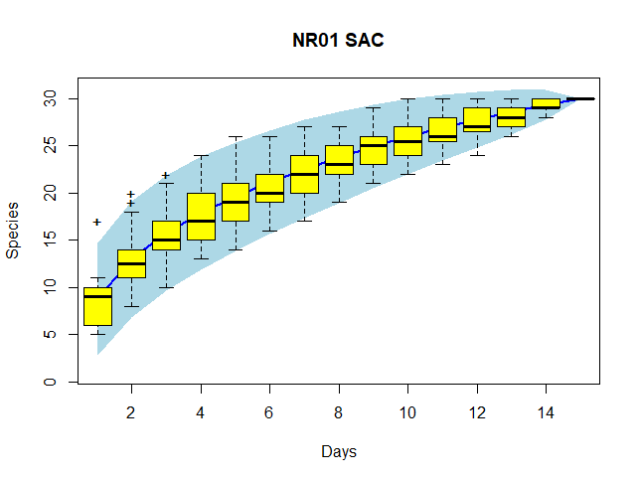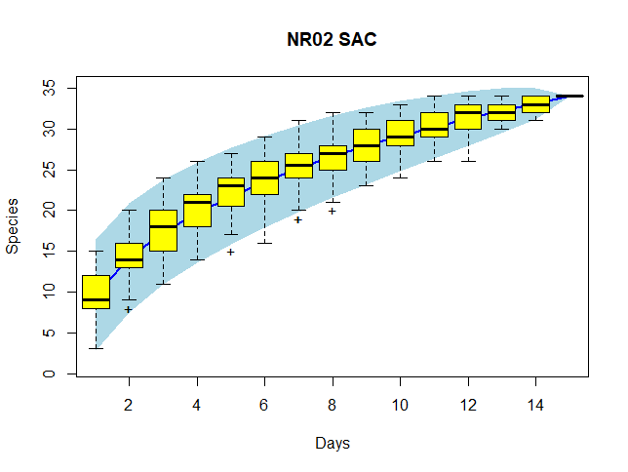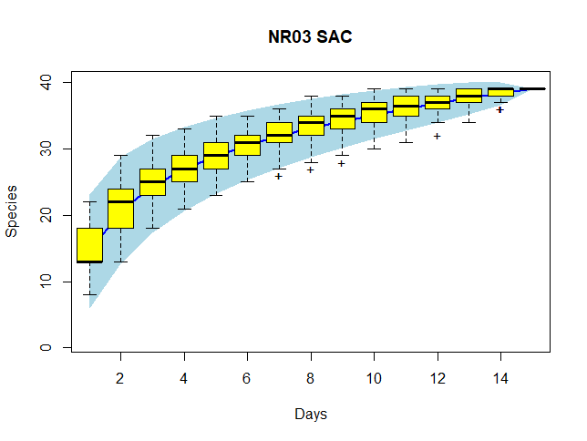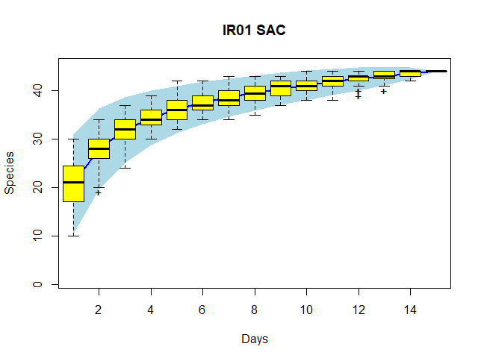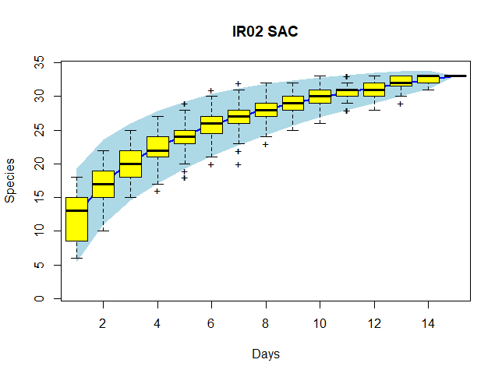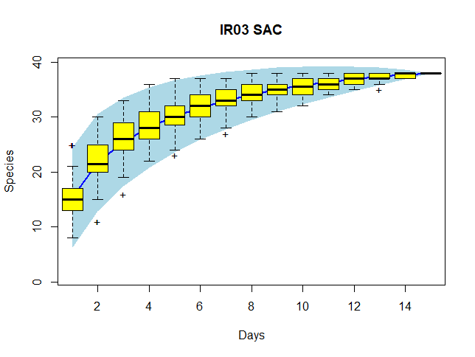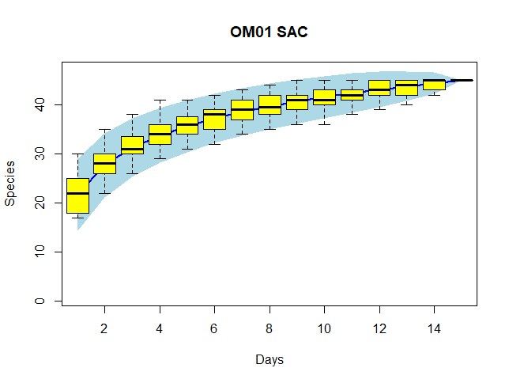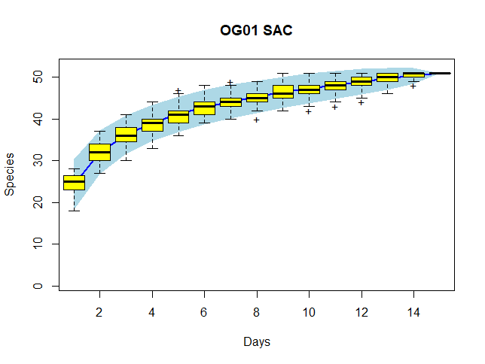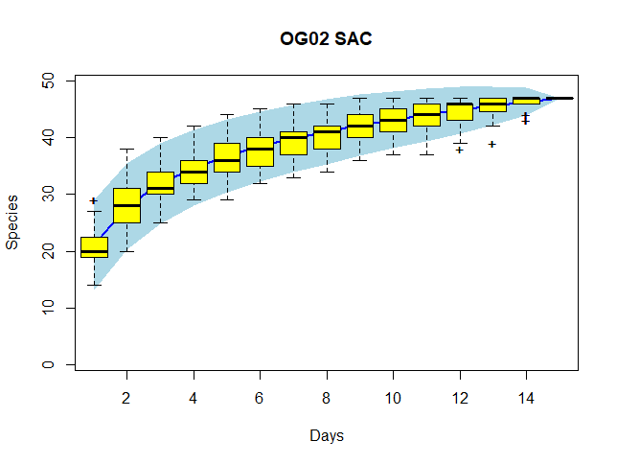

*Appendix C: Functional diversity matrix*

Functional diversity matrix used to calculate Petchey’s FD. *Indicates the one unknown honeyeater species of the study. This species’ size, primary food, and foraging height were calculated from all remaining possible honeyeater species that have been recorded at the site after known honeyeater species were removed. As all species were of a similar size, foraged at similar heights, and relied on the same food sources, they were merged together for the purpose of the calculations. This decision was made as the species is uncommon but still present in 10-24% of dawn choruses, as such may have played an important functional role for the site it was located.

|  |  |  |  |  |
| --- | --- | --- | --- | --- |
| Common | Length cm | Primary food type | Foraging height | Abundance |
| Australian Magpie | 40.5 | Invertebrates | 1 | 5 |
| Australian Raven | 51 | Carrion | 1 | 4 |
| Australian Ringneck | 36 | Seeds | 5 | 4 |
| Bar-shouldered Dove | 28.5 | Seeds | 1 | 2 |
| Black-eared cuckoo | 20 | Invertebrates | 2 | 2 |
| Black-faced Cuckoo-shrike | 33 | Invertebrates | 2 | 2 |
| Bourke's Parrot | 20.5 | Seeds | 1 | 2 |
| Brown Honeyeater | 14 | Nectar | 5 | 3 |
| Brown Treecreeper | 17 | Invertebrates | 3 | 3 |
| Chestnut-breasted quail-thrush | 22 | Invertebrates | 1 | 1 |
| Chestnut-rumped Thornbill | 9.5 | Invertebrates | 2 | 5 |
| Crested Bellbird | 21 | Invertebrates | 1 | 5 |
| Crested Pigeon | 33 | Seeds | 1 | 5 |
| Diamond Dove | 22 | Seeds | 1 | 2 |
| Double-barred Finch | 10.5 | Seeds | 1 | 1 |
| Fan-tailed Cuckoo | 26 | Invertebrates | 2 | 2 |
| Galah | 36.5 | Seeds | 1 | 2 |
| Grey Butcherbird | 28 | Reptiles | 4 | 4 |
| Grey Fantail | 15.5 | Invertebrates | 3 | 1 |
| Grey Shrike-thrush | 23.5 | Invertebrates | 5 | 3 |
| Grey-crowned Babbler | 27.5 | Invertebrates | 3 | 1 |
| Hall's Babbler | 23 | Invertebrates | 3 | 1 |
| Horsfield's Bronze-Cuckoo | 15.5 | Invertebrates | 3 | 4 |
| Inland thornbill | 10 | Invertebrates | 2 | 2 |
| Jacky Winter | 13 | Invertebrates | 2 | 3 |
| Laughing Kookaburra | 43.5 | Reptiles | 3 | 2 |
| Little Crow | 46.5 | Carrion | 1 | 1 |
| Little Friarbird | 27.5 | Invertebrates | 4 | 1 |
| Magpie Lark | 28 | Invertebrates | 1 | 2 |
| Major Mitchell's Cockatoo | 37.5 | Seeds | 5 | 4 |
| Masked woodswallow | 19.5 | Invertebrates | 5 | 3 |
| Mistletoebird | 10.5 | Fruits | 4 | 3 |
| Mulga Parrot | 28 | Seeds | 1 | 4 |
| Noisy Friarbird | 32.5 | Nectar | 4 | 5 |
| Pallid Cuckoo | 31 | Invertebrates | 3 | 2 |
| Peaceful Dove | 22 | Seeds | 1 | 3 |
| Pied Butcherbird | 34.5 | Reptiles | 5 | 4 |
| Rainbow Bee-eater | 25 | Invertebrates | 4 | 2 |
| Red-browed Pardalote | 11 | Invertebrates | 1 | 1 |
| Red-capped Robin | 11.5 | Invertebrates | 1 | 5 |
| Red-backed kingfisher | 22 | Reptiles | 4 | 1 |
| Red-rumped Parrot | 27 | Seeds | 1 | 2 |
| Red-winged Parrot | 31.5 | Seeds | 4 | 4 |
| Rufous Songlark | 17.5 | Invertebrates | 1 | 1 |
| Rufous Whistler | 16.75 | Invertebrates | 4 | 4 |
| Sacred Kingfisher | 21.5 | Reptiles | 3 | 1 |
| Shining Bronze-Cuckoo | 17 | Invertebrates | 4 | 1 |
| Singing Honeyeater | 20 | Nectar | 4 | 4 |
| Spiny-cheeked Honeyeater | 24.5 | Nectar | 5 | 5 |
| Spotted Bowerbird | 31 | Invertebrates | 1 | 3 |
| Spotted Nightjar | 30.5 | Invertebrates | 5 | 1 |
| Striated Pardalote | 10.5 | Invertebrates | 4 | 2 |
| Striped Honeyeater | 23.5 | Nectar | 2 | 3 |
| Welcome Swallow | 14.5 | Invertebrates | 5 | 2 |
| Western Gerygone | 10.5 | Invertebrates | 4 | 1 |
| Whistling Kite | 55 | Mammal | 1 | 2 |
| White-browed Treecreeper | 14.5 | Invertebrates | 3 | 2 |
| White-plumed Honeyeater | 16 | Invertebrates | 5 | 4 |
| White-winged Chough | 45 | Invertebrates | 1 | 2 |
| White-winged Fairywren | 12.5 | Invertebrates | 2 | 1 |
| Willie Wagtail | 20.5 | Invertebrates | 1 | 4 |
| Yellow Thornbill | 9.5 | Invertebrates | 4 | 2 |
| Yellow-rumped Thornbill | 11.5 | Invertebrates | 2 | 2 |
| Yellow-throated Miner | 27 | Invertebrates | 5 | 4 |
| Splendid fairywren | 13.5 | Invertebrates | 2 | 2 |
| Unknown Honeyeater species* | 24.5 | Nectar | 5 | 2 |